**Lab Session #1**

**Basic Mathematics Using Python**

**Aim:** To Learn Basic Python And Develop Programs To Solve The Given Mathematical Problems.

**Problem Definition**: Develop Python Programs To:

1. Convert Degrees To Radians And Vice Versa.
2. Calculate The Arc Length Of An Angle
3. Find Out If The Given Number Is Abundant. Note: In Number Theory, An Abundant Number Or Excessive Number Is A Number For Which The Sum Of Its Proper Divisors Is Greater Than The Number Itself. The Integer 12 Is The First Abundant Number. Its Proper Divisors Are 1, 2, 3, 4 And 6 For A Total Of 16.
4. Print The First N Lucky Numbers.

Lucky Numbers Are Defined Via A Sieve As Follows.

Begin With A List Of Integers Starting With 1 :

1, 2, 3, 4, 5, 6, 7, 8, 9, 10, 11, 12, 13, 14, 15, 16, 17, 18, 19, 20, 21, 22, 23, 24, 25, . . . .

Now Eliminate Every Second Number :

1, 3, 5, 7, 9, 11, 13, 15, 17, 19, 21, 23, 25, ...

The Second Remaining Number Is 3, So Remove Every 3rd Number:

1, 3, 7, 9, 13, 15, 19, 21, 25, ...

The Next Remaining Number Is 7, So Remove Every 7th Number:

1, 3, 7, 9, 13, 15, 21, 25, ...

Next, Remove Every 9th Number And So On.

Finally, The Resulting Sequence Is The Lucky Numbers.

1. Find the roots of a quadratic function.

**Theory:** Python is a high-level, general-purpose, and very popular programming language. Python programming language (latest Python 3) is being used in web development, Machine Learning applications, along with all cutting-edge technology in the Software Industry. Python language is being used by almost all tech-giant companies like – Google, Amazon, Facebook, Instagram, Dropbox, Uber… etc. The biggest strength of Python is huge collection of standard library which can be used for the following:

* Machine Learning
* GUI Applications (like Kivy, Tkinter, PyQt etc. )
* Web frameworks like Django (used by YouTube, Instagram, Dropbox)
* Image processing (like OpenCV, Pillow)
* Web scraping (like Scrapy, BeautifulSoup, Selenium)
* Test frameworks
* Multimedia
* Scientific computing
* Text processing and many more..

Python is currently the most widely used multi-purpose, high-level programming language, which allows programming in Object-Oriented and Procedural paradigms. Python programs generally are smaller than other programming languages like Java. Programmers have to type relatively less and the indentation requirement of the language makes them readable all the time.

List, Tuple, Set, and Dictionary are the data structures in python that are used to store and organize the data in an efficient manner.

Lists: are just like dynamic sized arrays, declared in other languages (vector in C++ and ArrayList in Java). Lists need not be homogeneous always which makes it the most powerful tool in Python.

Tuple: A Tuple is a collection of Python objects separated by commas. In some ways, a tuple is similar to a list in terms of indexing, nested objects, and repetition but a tuple is immutable, unlike lists that are mutable.

Set: A Set is an unordered collection data type that is iterable, mutable, and has no duplicate elements. Python’s set class represents the mathematical notion of a set.

Dictionary: in Python is an ordered (since Py 3.7) [unordered (Py 3.6 & prior)] collection of data values, used to store data values like a map, which, unlike other Data Types that hold only a single value as an element, Dictionary holds key:value pair. Key-value is provided in the dictionary to make it more optimized.

1)

**Code:**

def deg():

deg = float(input("Enter the measure in degrees."))

print("The radian measure is: ", deg*3.14/180)

def rad():

rad = float(input("Enter the measure in radians."))

print("The degree measure is: ", rad*180/3.14)

inp = int(input("Enter 1 for degrees and 2 for radians."))

if (inp == 1):

deg()

elif (inp == 2):

rad()

else:

print("Invalid input.")

**Output:**

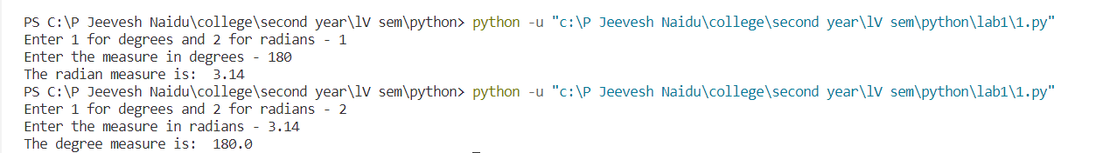

2)

**Code:**

angle = float(input("Enter the angle in radians.")) % 6.28

radius = float(input("Enter the radius in metres."))

print("The arc length in metres is : ", angle*radius)

**Output:**



3)

**Code:**

num = int(input("Enter the number to be checked."))

sum = 0

for i in range(1, (num//2)+1):

if (num % i == 0):

sum += i

if (sum > num):

print("The number is an abundant number.")

else:

print("The number is not an abundant number.")

**Output:**

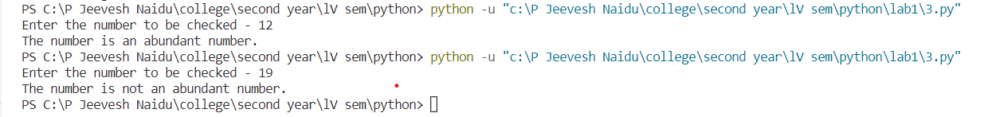

4)

**Code:**

n = int(input("Enter n."))

arr = [i+1 for i in range(2**n)]

for i in range(1, 2**n//2):

if arr[i] == 0:

continue

num = arr[i]

count = 0

for j in range(2**n):

if arr[j] != 0:

count += 1

if (count % num == 0):

arr[j] = 0

count = 0

for i in range(2**n):

if arr[i] != 0:

count = count+1

if (count <= n):

print(arr[i], end=" ")

else:

break

print()

**Output:**

5)

**Code:**

a, b, c = list(map(int, input(

"Enter the coefficients of the x^2,x and constant term.").split()))

x1 = ((-1*b)+((b**2)-(4*a*c))**0.5)/(2*a)

x2 = ((-1*b)-((b**2)-(4*a*c))**0.5)/(2*a)

print("The roots of the equation are: ", x1, x2)

**Output:**

